PHP Quick Menu
Esta clase PHP permite crear un menu Html a partir de una string Json. Por favor califica este repositorio, pues de esa forma voy a saber que este trabajo está siendo útil. La clase tiene parámetros de configuración, explicados en este tutorial: http://codeignitertutoriales.com/php-menu-dinamico-multinivel/
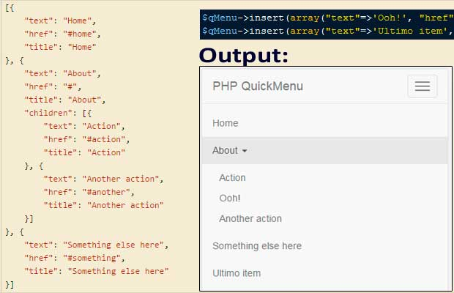

Input
[{
"text": "Home",
"href": "#home",
"title": "Home"
}, {
"text": "About",
"href": "#",
"title": "About",
"children": [{
"text": "Action",
"href": "#action",
"title": "Action"
}, {
"text": "Another action",
"href": "#another",
"title": "Another action"
}]
}, {
"text": "Something else here",
"href": "#something",
"title": "Something else here"
}]

Output
<ul class="nav navbar-nav" id="#myMenu">
<li><a href="#home" title="Home">Home</a></li>
<li class="dropdown">
<a href="#" title="About" class="dropdown-toggle" data-toggle="dropdown" role="button" aria-haspopup="true" aria-expanded="false">About <i class="caret"></i></a>
<ul class="dropdown-menu">
<li><a href="#action" title="Action">Action</a></li>
<li><a href="#another" title="Another action">Another action</a></li>
</ul>
</li>
<li><a href="#something" title="Something else here">Something else here</a></li>
</ul>

How to use
- Extend the QuickMenu class for customization. For instance Bootstrap menu. (This is optional)
require 'QuickMenu.php';
class BootstrapMenu extends QuickMenu
{
public function __construct($options = array())
{
parent::__construct($options);
$this->setDropDownIcon('<i class="caret"></i>');
$this->set('ul-root', array('class'=>'nav navbar-nav', 'id'=>'#myMenu'));
$this->set('ul', array('class'=>'dropdown-menu'));
$this->set('li-parent', array('class'=>'dropdown'));
$this->set('a-parent', array('class'=>"dropdown-toggle", 'data-toggle'=>"dropdown", 'role'=>"button", 'aria-haspopup'=>"true", 'aria-expanded'=>"false"));
}
}
- Include your class
include "BootstrapMenu.php";
$str = '[{"text":"Home", "href": "#home", "title": "Home"}, {"text":"About", "href": "#", "title": "About", "children": [{"text":"Action", "href": "#action", "title": "Action"}, {"text":"Another action", "href": "#another", "title": "Another action"}]}, {"text":"Something else here", "href": "#something", "title": "Something else here"}]';
- Instance the class with data parameters
$qMenu = new BootstrapMenu(array('data'=>$str));
- Use the methods availables
$qMenu->setActiveItem('http://codeignitertutoriales.com');
$qMenu->insert(array("text"=>'Ooh!', "href"=>'http://codeignitertutoriales.com', "title"=>'Awesome'), 'Another action', 'About');
$qMenu->insert(array("text"=>'Ultimo item', "href"=>'https://github.com/davicotico', "title"=>'My Github'));
- Renderize the menu in a string variable
$menu = $qMenu->html();
- Done. You can echoes the menu on html document
<div id="navbar" class="navbar-collapse collapse">
<?php echo $menu ?>
</div>

Class reference

setActiveItem($href, $activeClass = '')
Setting the active item.
Parameters:
- string $href The active href
- string $activeClass (Optional) The Css class for the active item

insert($item, $before_at = '', $parent = '')
Insert an item
Parameters:
- array $item - Associative array with item attributes (text, href, icon, title)
- string $before_at (Optional) The reference position for insert
- string $parent (Optional) The parent if the insert is in submenu

remove($text)
Remove an item (from top level) by text attribute
Parameters:
- string $text Text item

replace(array $newItem, $text)
Replace an item (find by text attribute)
Parameters:
- array $newItem The new item
- string $text The text item for search

html()
The Html menu
return: string Html menu

setData($data)
Setting the data from json string or associative array
Parameters:
- mixed $data Data (Json string or associative array)

setResult($result, $columnID, $columnParent)
Set result from query database
Parameters:
- array $result The resultset
- string $columnID The ID column name (Primary key)
- string $columnParent The column name for identify the parent item

setDropdownIcon($content)
Set dropdown icon for display with submenus
Parameters:
- string $content Content for the dropdown icon (Html code)

set($name, $value)
Set the attributes for the tag vars
Parameters:
- string $name Var name
- mixed $value Var value
Var names: 'ul', 'ul-root', 'li', 'li-parent', 'a', 'a-parent', 'active-class'

